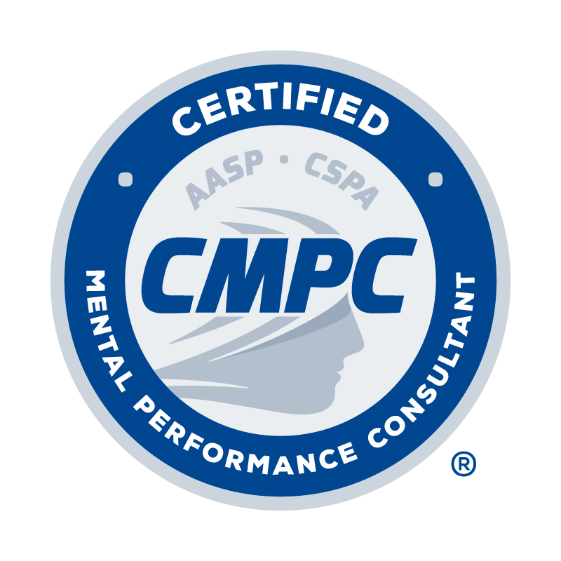

REGISTRY OF APPROVED MENTORS
APPLICATION FORM
(for Active CMPC mentors)

Application Date:

The Registry of Approved Mentors lists experienced practitioners who devote a substantial amount of their professional time to the practice of applied sport psychology in sport organizations and related settings. They devote significant professional time to the assessment and teaching of mental skills for performance to athletes, teams, and other high-level performers. Their commitment and their identity with the field of sport psychology is exemplified by their long-standing memberships in major sport psychology organizations, attendance and presentations at sport psychology conferences, and other relevant activities. Additionally, they are experienced in the mentoring process by virtue of their own mentored experiences and/or extensive mentoring of students and early career professionals.

Since the CMPC is focused on enhancing performance through mental skills training, teaching, providing athletes with counseling or mental health services are not the primary professional activities of those listed in the Registry.

Effective January 1, 2023, newly credentialed first-time CMPC’s may apply for listing in the Registry of Approved Mentors two years after their CMPC is awarded or five years after their appropriate graduate degree. During this time, it is expected that they will continue developing their professional sport psychology consulting skills by providing mental skills assessment and training to athletes and/or other performers. A minimum of 200 contact hours of direct services to athletes and/or other performers is required after the completion of the 400 mentored hours.

All applicants listed in the Registry of Approved Mentors must provide verification of six hours of continuing education in mentoring/supervision. This can include a university course, or programs and webinars provided by AASP, CSPA, APA, or other reputable professional organizations.

I. PERSONAL INFORMATION

Last Name: First Name: Middle Initial:

Current Affiliation and Position:

Home Address: check if preferred mailing address Business Address: check if preferred mailing address
Home Phone: | Business Phone:

Email Address:

Year You Were First Certified as a CMPC: List All Degrees Obtained & Graduation Year for Each:

II. CONTINUING EDUCATION (CE) ACTIVITY LOG

Complete the Continuing Education Activity Log by following the instructions provided below. Refer to the Candidate Handbook for requirements related to continuing education units (CEUs) for approved mentors.
- Type of CE Activity: Select the type of CE activity completed from the drop-down menu. Options include Conference, Webinar, Presentation, Workshop, Academic activity. Refer to the Candidate Handbook for descriptions of acceptable CE activities.
- Name of CE Activity: Record the title of session/activity completed.
- Hosting Organization: Record the organization that hosted the CE activity.
- Date: Record the date the CE activity occurred.
- # of CEUs: Record the number of CEUs awarded for each activity. Refer to the Candidate Handbook for information regarding the number of CEUs awarded for various activities.
Provide documentation as evidence of completion for each CE activity as outlined in the CE Activity table provided in the Candidate Handbook. Documentation is required for each CE activity as indicated in the CE Activity table.

TYPE OF  CE ACTIVITY | NAME OF CE ACTIVITY | HOSTING ORGANIZATION | DATE | # of CEUs
Webinar | Best Practices in Supervision for Developing Competent Consultants | AASP | July 2020 | 1.25
TOTAL # OF CEUs |  |  |  | 0.00

III. ATTESTATION AND ETHICAL CODE

I have read and understand the CMPC® Certification Program Candidate Handbook, especially the Mentored Experience Requirements outlined in Section One, and agree to abide by the policies of the Certification Council and AASP as described therein, including the confidentiality and disciplinary rules. I understand that the information I provide to the Certification Council may be audited, and I authorize the Council to make any necessary inquiries in this regard.

By applying for inclusion in the Registry of Approved Mentors, I agree to adhere to the AASP Ethics Code and to having read the CMPC® Mentor Guidelines and Best Practice Recommendations. I understand that any violation of any portion of the AASP Ethics Code may result in disciplinary action as outlined in the Disciplinary and Complaints Policy of the Candidate Handbook.

I certify that the information contained in this application for inclusion in the Registry of Approved Mentors is true, complete, and correct to the best of my knowledge. I understand that the submission of false or misleading information at any time may be the cause for revocation of this application and/or listing in the Registry, without refund of any fees.

Signature of Applicant Date

To submit application:

- Combine and convert the completed application form and curriculum vitae/resume into a single PDF.

Email PDF to Leilani Madrigal, PhD, CMPC, Mentoring Committee Chair, at Leilani.madrigal@csulb.edu with the subject line “Registry Application_First Initial Last Name

