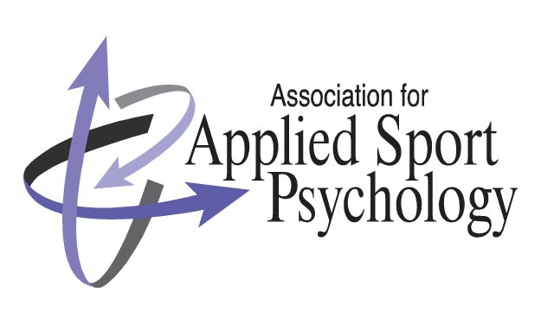

http://appliedsportpsych.org
Learn more about Sport and Exercise Psychology
Through the Association for Applied Sport Psychology (AASP) and the Proactive Peer Undergraduate Mentoring Program (PPUMP)

What’s New?!
FAQ’s:

How can I find out more information about the field of Sport and Exercise Psychology and AASP?

Proactive Peer Undergraduate Mentoring Program (PPUMP)

PPUMP is comprised of graduate students who are competent and willing to serve as mentors for their peers and prospective students as they search for graduate programs that best fit their needs. Send an email to: ppump@aaasponline.org
to contact a PPUMP representative!

You can also find out more information about the field of sport and exercise psychology and AASP online at:
http://appliedsportpsych.org

How can I learn more about graduate programs in Sport and Exercise Psychology?

A Graduate Program Fair is held each year at the annual AASP conference.

At the fair, you can meet current students and professors of master’s and Ph.D. programs in the field. This is a great opportunity to learn more about various programs, as well as the research interests of faculty and graduate students in the field. Find out more about how to attend the AASP annual conference on the AASP website.

On the website you can visit the “Students” tab then “Graduate Training” for a list of resources and access to the PPUMP mentor database.
There is also a Directory of Graduate Programs in Applied Sport Psychology available at: www.fitinfotech.com – the directory covers over 100 MA/MS and Ph.D. programs worldwide!

Conference Information:
The 28th Annual Conference is in New Orleans, Louisiana on October 2-5th, 2013. You may register for conference at a reduced student rate – this is a great way to meet students and professionals in the field, have fun, and learn more about sport and exercise psychology!

What is Applied Sport Psychology?
- Applied sport psychology involves extending theory and research into the field to educate coaches, athletes, and parents with the goals of facilitating optimal sport involvement and performance. AASP incorporates information and expertise from exercise and sport sciences and from psychology. The Association is comprised of three interrelated focus areas: Performance Psychology, Health and Exercise Psychology, and Social Psychology.
- Performance Psychology focuses on research, theory, and practice intended to improve performance in exercise and sport. The area is also concerned with the effects of sport psychology interventions on the well-being of participants in exercise and sport. Although there are many specific concepts within applied sport psychology (e.g., goal setting, relaxation, concentration, imagery), the general goal is to teach individuals in various fields (e.g., sports, business, performing arts) the mental skills necessary to perform consistently and to help them realize their full potential.
- Health and Exercise Psychology focuses on the application of psychological principles to the promotion and maintenance of health-enhancing behaviors over the lifespan, including play, leisure physical activity and structured exercise, and the psychological and emotional consequences of those behaviors. Researchers in this area also investigate the role of exercise in disease remediation, injury rehabilitation, and stress reduction.
- Social Psychology focuses on individual and group processes in sport and exercise settings. This area applies social psychological principles in examining factors related to the sport participant, coach, team, and spectator.

Interested in a Career in Applied Sport Psychology?
In a 2003 article in the Journal of Applied Sport Psychology, Williams and Scherzer asked individuals who graduated from a masters or doctoral program, with an emphasis in sport psychology, about their current position of employment, income, career goals, and sport psychology consulting aspirations.

The findings provide some helpful guidelines for current and prospective students regarding graduate training and career opportunities.

Some career opportunities include:

- Performance Enhancement Consultant for:
  - Athletes
  - Businesses
  - Military Personnel
- Professor in Kinesiology and Psychology/Counseling Departments
- Professional in sports medicine/medical settings

