Athlete Mental Health and Safety: Suicide and Suicide Prevention
John Heil
This is difficult article to write, about a difficult conversation to have. It is about mental health challenges when athletes don’t survive them. It is about suicide.
Between March and April of 2022, 3 successful collegiate student athletes committed suicide: Katie Meyer (Stanford University), Sarah Schulze (University of Wisconsin) and Lauren Bennett (James Madison University).
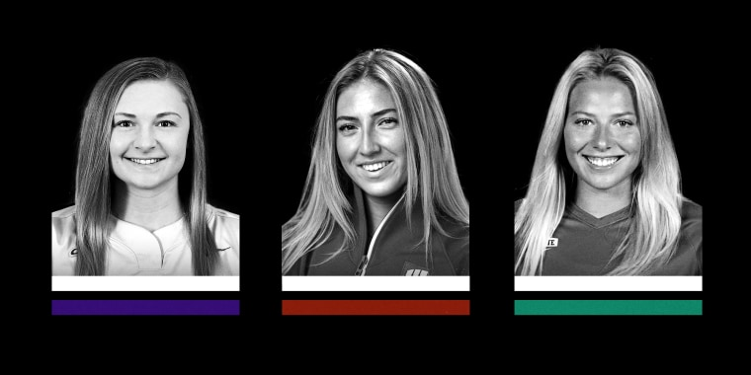
Unfortunately, their stories and tragic early passings are just the tip of the iceberg with regards to depression and suicide. In the USA in 2020, there were over a million suicide attempts, with about 130 actual suicide completions each day. According to the Centers for Disease Control and Prevention, suicide deaths for women and girls more than doubled between the years 2001 and 2020, while for men and boys the same figure increased by 60%. This is part of a growing trend in mental health problems that has been most likely worsened by the pandemic. Athletes and student athletes, specifically, have been directly affected, prompting initiatives from the NCAA and the International Olympic Committee. While professional mental health access and sport organizational response are essential, there is more that can and needs to be done. Bystander intervention programs focus on helping friends and teammates take action when someone appears to be struggling emotionally. The more who are engaged and informed, the better.
However, with cases of completed suicide, there comes an understandable shock wave of loss, grief, and confusion for family, friends, teammates and schoolmates. Inevitably there are questions, like “Why did this happen?”, “What are the signs?”, “How could it have been prevented?” or “Could I have done more?”.
Many potential suicides are stopped before completion. Below, I will discuss reasons why suicidal thoughts and actions may arise, the signs of suicide risk, and what coaches, teammates, and family members can do to provide support for someone struggling with suicidal ideation.
Personally, as a psychologist, I find encounters with suicidal persons both extremely challenging and critically important, even with professional training and years of experience in the mental health field. I have been witness to the devastating impact of suicide on loved ones. I’ve helped to successfully manage multiple suicide crisis situations, including once at a NAC. I have also been deeply saddened to learn of a fencer’s death by suicide at World Championships, after their perceived poor performance. My personal takeaways from these experiences are: trying to help matters, authenticity in expressing concern is extremely important, and accepting that sometimes everyone’s best efforts are not enough. The most important of these lessons, is worth repeating: showing up authentically and in a supportive and direct manner will prevent some suicides.
While it may be difficult to understand how an athlete could consider taking their own life, the “why” is often clearer. Depression and suicide may stem from personal loss, grief, or disappointment, or feelings of rejection and humiliation – on or off the field of play. Alcohol and drug use oftentimes exacerbate these feelings. A cohesive support system, available resources, and compassionate and caring teammates may serve as lines of defense for those who are struggling.
Understanding why an individual may experience suicidal ideation or planning is a first step – what signs to look for and how to respond with care and knowledge, follow. Most importantly, if you recognize signs of low mood, withdrawal, change of appetite, or any out of the ordinary behavior, it’s important to reach out to the person. This might be as simple as “I’ve noticed you seem down. How are you feeling?” or “It seems like you have been having a rough time lately, I’m concerned about you.” Next, listen actively and carefully! Often times, when asked with care and compassion, individuals will want to express how they feel and what they may be going through. If you have relevant personal experience, consider whether it may be appropriate to share it. Importantly, it is reasonable to ask clear and direct question about suicide. It is a myth that discussing suicide, and suicidal ideation and planning (even just using the word), will encourage individuals to complete suicide. Remember to keep listening, even if you are uncomfortable. Above all, encourage the person struggling to seek mental health treatment and be willing to offer to help them through this process. If the person is displaying imminent risk of harming themselves, stay with them and call or text 988, the national suicide and crisis lifeline for further help and support.
Some who are in distress will be on the edge of disclosure, hesitant and reluctant to acknowledge suicidal thoughts or feelings, but leaving you feeling very uncomfortable with their emotional state. You may consider saying something like: “There has been a lot about mental health and suicide in the news recently. It seems that often people are in distress but are afraid to speak about it. If this were the case with you, I hope you would be able to talk with me or someone else about this.” You may help this along by pointing out that many athletes, even great ones like Simone Biles and Michael Phelps, have suffered mental health problems, speaking openly about them. In this situation, be patient and listen carefully, in particular for signs of “unlovability” (no one really cares), “unbearability” (feelings that are too intense to live with), and “unsolvability” (there is no solution in sight). Showing sincere interest counters feelings of unlovability, may diminish the sense of unbearability, and help with identifying a path to a solution.
If you are not prepared to be open or willing to recognize the validity of another person’s feelings, whether you agree with them or not, you should not try to help them. Do not engage in a philosophic or moral discussion about suicide. Do not suggest that suicide is a desirable alternative, or that the person is not serious.
It’s important to know and be armed with resources. The national Suicide & Crisis Lifeline can be reached by calling or texting 988. This is not only for those who may be considering suicide but also those who are concerned about others, or assisting someone experiencing a crisis. Extensive information, including social media shareables, is available at the website: https://www.samhsa.gov/find-help/988. I’ve included various other resources and educational information regarding the care and management of crises, below.
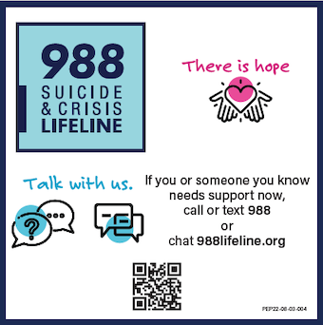
Other Resources:
StepUp! developed by Becky Bell with the University of Arizona and the NCAA offers a wide range of bystander intervention programs including depression and suicide prevention, as well as, as hazing and sexual assault.
https://stepupprogram.org/
The Jed Foundation focuses on emotional health and suicide prevention among teens and young adults
https://jedfoundation.org/
There is a Suicide Assessment Guide available at: ZenZoneDigital.net

Dr. John Heil is a sport and clinical psychologist, who served as chair of USA Fencing Sports Medicine & Science for 15 years, and as a sport psychology consultant at 3 Olympic Games.
Nicole Ross, who is a doctoral student in clinical psychology, shared in the preparation of the article and offered her perspective as an Olympic athlete.
Thanks also to Dr Ina Harizanova and Dr. Rich Gordin for their review and comments

