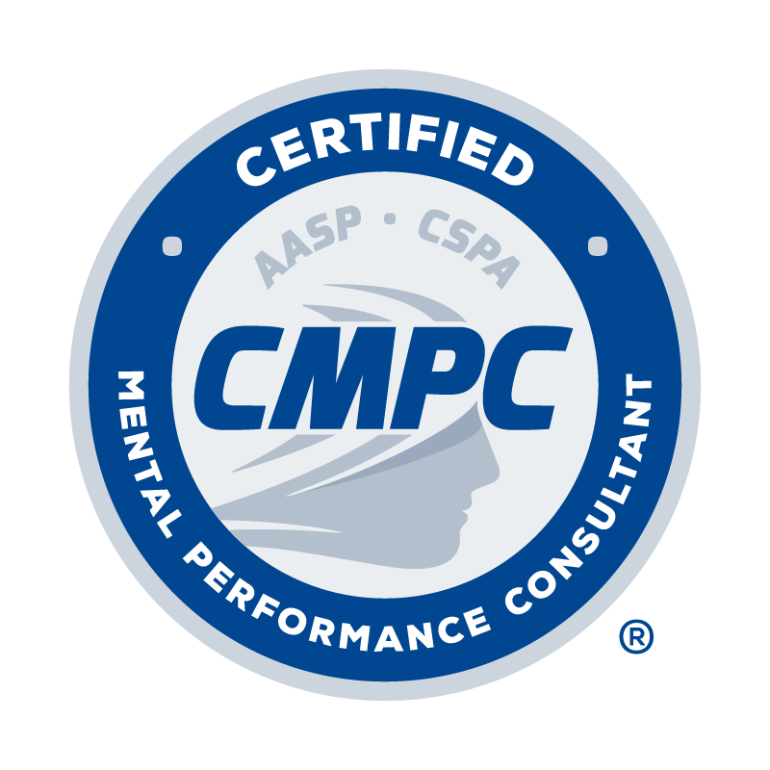
ALL SECTIONS OF THIS FORM MUST BE TYPED

Complete the Record of Mentored Experience Hours Form by following the instructions provided. Documentation and verification of a 400-hour mentored experience is required. The 400-hour mentored experience consists of a minimum of 200 hours spent in direct client contact, a minimum of 150 hours spent in support activities, and a minimum of 50 hours spent in mentorship (i.e., face-to-face mentorship, electronic mentorship, and direct knowledge of services). A minimum of 100 hours across these categories must be with competitive sport populations. See the instructional page for complete descriptions of these categories and specific hour requirements. Mentored experiences can be completed during the applicant’s graduate education or as a post-graduate experience. Each mentor listed on the Record of Mentored Experience Hours Form must complete a Mentorship Verification Form. This form can be downloaded from the Mentored Experience step in Certemy and from the Application Forms page of the AASP website.

Mentor Approval: Mentors for the mentored experience must be approved by the Certification Council. All Certified Mental Performance Consultants® (CMPCs) who document the completion of required continuing education in mentorship/ supervision are listed in the Registry of Approved Mentors and approved to provide mentorship. Non-certified mentors can be approved for listing by submitting the Registry of Approved Mentors Application Form. They can maintain their listing by completing required continuing education in mentorship/supervision and other professional practice areas. It is the applicant’s responsibility to ensure that mentors for their mentored experience are approved by the Certification Council. Applicants are encouraged to confirm that mentors are approved before beginning their mentored experience and maintain approval throughout to avoid the risk of the accumulated hours not being eligible to be counted.

Eligible Activities: Only time spent in direct client contact, support activities, and mentorship in an applied sport/performance psychology setting are eligible to be counted toward the mentored experience hours. If in doubt, please provide detailed information and/or contact the Chair of the Certification Council for clarification. Examples of activities that are considered eligible and ineligible for the required mentored experience include but are not limited to:

Examples of eligible activities:

- Working with individual athletes, performing artists, military personnel, and other relevant performers on performance-related issues (e.g., motivation, confidence, performance anxiety, arousal control, injury rehabilitation).
- Consulting directly with an athletic or performance team and teaching mental skills such as goal-setting, relaxation/activation, concentration, imagery, self-talk, and performance routines.
- Consulting with an administrator (e.g., athletic director, general manager) about how to effectively incorporate mental skills development programs into operating routines of the particular organization
- Serving as a youth sports organization consultant educating parents, athletes, and/or coaches about healthy competition patterns, moral reasoning, and life skills.
- Working as an academic counselor and providing formal training (e.g., stress management, problem-solving, goal setting, time management) to athletes related to performance enhancement.
- Working as an intern in a corporation and providing exercise intervention programs to improve the psychological well-being of employees.

Example of ineligible activities:

- Serving as a team’s athletic coach, athletic trainer, or strength coach.
- Working in an alcohol rehabilitation center that happens to have athletes or other performers as clients.
- Providing marital and family counseling to athletes, dancers, or soldiers and their families.
- Contracting with professional sports teams to do a psychometric work-up of players to make a psychological diagnosis.
- Being part of a general counseling practice treating an athlete or other performer for an eating disorder.
- While completing an internship in psychology, prescribing running as part of clinical therapy.
- While serving as an academic counselor, providing academic support services to athletes.
- As an intern hired by a corporation you use performance enhancement interventions to address mental health issues of their employees.

Instructions for Completing the Record of Mentored Experience Hours Form

1. Dates of Service: List the starting and ending month/year related to time spent in the sport or activity.

2. Name of Mentor: List the name of your mentor who provided mentorship related to time spent in the sport or activity.

3. Level/Setting of Sport or Activity: Specify the type of sport or activity in which time was spent along with the level of participants. For example: college baseball team, recreational marathon runner, junior high school wrestler, basic training military unit, professional musician. A minimum of 100 hours (Direct Client Contact) of the 400 total hours must be spent with competitive sport populations. The remaining 300 hours can be spent with sport or non-sport (e.g., exercisers, performing artists, military service organizations, high-risk occupations) populations.

Performance Context
The CMPC credential is historically grounded in sport psychology conducted within traditional competitive sport contexts and samples. This discipline has a rich history of over 100 years of scholarship that produced knowledge and principles used in interventions by professionals aiming to enhance mental performance. As such, at least 100 Direct Client Contact mentored experience hours must occur within the “sport” contexts.
- “Sport” context includes skillful, effortful, physical activity engaged in by individuals, groups or teams in which they compete athletically against one another, in relation to a defined performance standard, and based on explicit rules of engagement.
- All other performance-related contexts (exercisers, performing artists, military service organizations, high-risk occupations, etc.) are defined as “non-sport” contexts.

4. Hours Spent in Direct Client Contact: Record the number of hours spent in in-person contact with individuals (e.g., athlete, coach, exerciser, performing artist, soldier) or groups (e.g., sport team, coaching staff, fitness class, dance troupe, military unit) working on mental skills to optimize performance, involvement, enjoyment, and/or personal development. Activities include individual consultation, group facilitation and consultation, psychoeducational workshops, and team-building exercises. A minimum of 200 of the 400 total hours must be spent in direct client contact.

5. Hours Spent in Support Activities: Record the hours spent in activities that pertain to individual or group clients but do not involve direct client contact. Activities include onsite observation of individual or group clients, record keeping and report writing, reviewing case notes or video/audio recordings, researching and preparing materials for intervention sessions, assessment scoring and interpretation, and case management (e.g., referral, consultation with other professionals). A minimum of 150 of the 400 total hours must be spent in support activities.

6. Mentorship Hours Spent:
Mentorship is defined as time spent by a mentor with the purpose of enhancing the mentee’s professional functioning. Time spent in mentorship can include in‐person meetings (i.e., mentee and mentor are physically present in the same location), distance meetings (i.e., mentee and mentor are not in the same location and interact through a synchronous audio and/or video format), and electronic communication (e.g., email). The mentor shall base the intensity of mentorship on the mentor’s professional judgment of the mentee’s credentials, years of experience, and the complexity of the cases with which the mentee works. It is recommended that mentees receive at least 1 hour of mentorship for every 10 hours of client contact.
a. Individual mentorship is defined as mentorship time spent between one mentor and one mentee. Students must spend a minimum of 20 hours with a mentor in individual mentorship.

b. Group mentorship is defined as mentorship time spent by one mentor and no more than 15 mentees in a group setting.

A minimum of 40 hours are required for mentorship hours. A minimum of 20 hours of these hours are needed in individual mentorship. The remaining 20 hours may be spent in individual or group mentorship. No mentorship hours should be recorded without Direct Client Contact.

7. Hours of Direct Knowledge of Services: Record the hours your mentor observed your skills and provision of services via samples of your work using modalities such as onsite observation, audio or video recordings, live streaming, test and questionnaire protocols, client homework, and/or other client-generated materials. While more direct knowledge of service hours can be accumulated, only 10 hours are needed for this area.

8. Skills Employed During Interventions: Record the types of skills or interventions used with individuals or groups. For example: goal setting, relaxation training, attentional focus, imagery, team building, relationship-building, etc.

Structure for Mentored Experience Hours
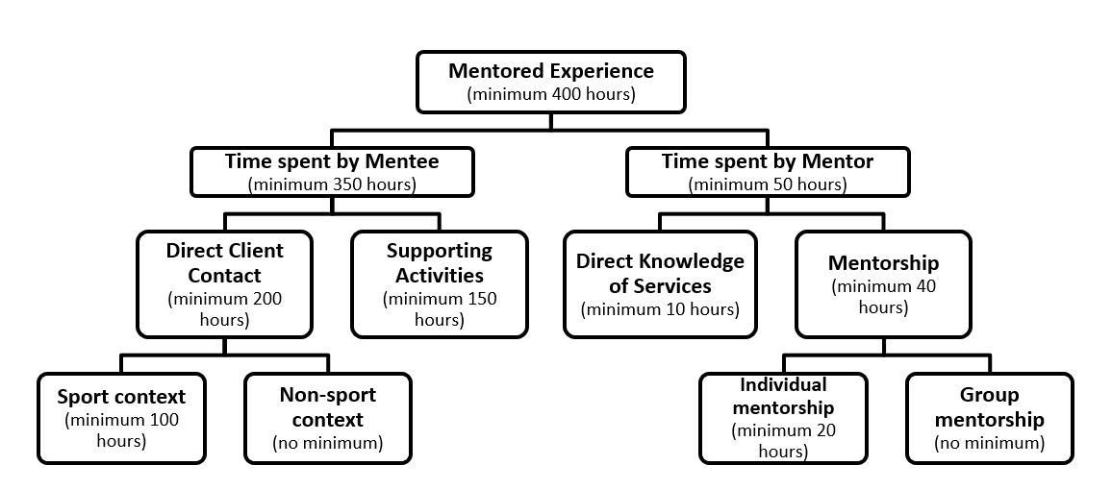

Use the hours log on the next page to document your mentored experience hours. If additional entry space is needed, use the second and/or third Record of Mentored Experience Hours Form below. If you have more than one mentor and are using both forms, organize your hours so all hours with each mentor are on their respective form as much as possible.
RECORD OF MENTORED EXPERIENCE HOURS FORM
(See instructional page for guidelines in completing this form)

The Record of Mentored Experience Hours Form should be completed before the Mentor Verification Forms. First, complete this Hours Form with all documented hours and then send this with the Mentor Verification Forms to your approved mentor(s) for sign-off.

Dates of Service | Name of Mentor | Level / Setting of Sport or Activity | Direct Client Contact  (minimum 200 hours) |  | Supporting Activities  (minimum  150 hours) | Mentorship Hours  (minimum 40 hours) |  | Total Hours Sport / Activity  (minimum 350 hours) | Direct Knowledge of Services  (minimum  10 hours) |  | Skills Employed During Interventions with Individuals and/or Groups
 |  |  | Sport  context  (minimum  100 hours) | Non-sport context  (no minimum) |  | Individual  (minimum 20 hours) | Group  (no minimum)
01/2023 to 01/2024 | Dr. Sport Psych | College baseball team | 25.00 | 0.00 | 3.00 | 10.00 | 1.00 | 39.00 | 1.00 | Goal setting, attentional focus, negative thought stopping, team building
 |  |  |  |  |  |  |  | 0.00
 |  |  |  |  |  |  |  | 0.00
 |  |  |  |  |  |  |  | 0.00
 |  |  |  |  |  |  |  | 0.00
 |  |  |  |  |  |  |  | 0.00
 |  |  |  |  |  |  |  | 0.00
 |  |  |  |  |  |  |  | 0.00
 |  |  |  |  |  |  |  | 0.00
 |  |  |  |  |  |  |  | 0.00
 |  |  |  |  |  |  |  | 0.00
 |  |  |  |  |  |  |  | 0.00
 |  |  |  |  |  |  |  | 0.00
 |  |  |  |  |  |  |  | 0.00
 |  |  |  |  |  |  |  | 0.00
 |  |  |  |  |  |  |  | 0.00
 |  |  |  |  |  |  |  | 0.00
 |  |  |  |  |  |  |  | 0.00
 |  |  |  |  |  |  |  | 0.00
 |  |  | 0.00 | 0.00 | 0.00 | 0.00 | 0.00 | 0.00 | 0.00 | 0.00 Total Hours

RECORD OF MENTORED EXPERIENCE HOURS FORM
(See instructional page for guidelines in completing this form)

The Record of Mentored Experience Hours Form should be completed before the Mentor Verification Forms. First, complete this Hours Form with all documented hours and then send this with the Mentor Verification Forms to your approved mentor(s) for sign-off.

Dates of Service | Name of Mentor | Level / Setting of Sport or Activity | Direct Client Contact  (minimum 200 hours) |  | Supporting Activities  (minimum  150 hours) | Mentorship Hours  (minimum 40 hours) |  | Total Hours Sport / Activity  (minimum 350 hours) | Direct Knowledge of Services  (minimum  10 hours) |  | Skills Employed During Interventions with Individuals and/or Groups
 |  |  | Sport  context  (minimum  100 hours) | Non-sport context  (no minimum) |  | Individual  (minimum 20 hours) | Group  (no minimum)
01/2023 to 01/2024 | Dr. Sport Psych | College baseball team | 25.00 | 0.00 | 3.00 | 10.00 | 1.00 | 39.00 | 1.00 | Goal setting, attentional focus, negative thought stopping, team building
 |  |  |  |  |  |  |  | 0.00
 |  |  |  |  |  |  |  | 0.00
 |  |  |  |  |  |  |  | 0.00
 |  |  |  |  |  |  |  | 0.00
 |  |  |  |  |  |  |  | 0.00
 |  |  |  |  |  |  |  | 0.00
 |  |  |  |  |  |  |  | 0.00
 |  |  |  |  |  |  |  | 0.00
 |  |  |  |  |  |  |  | 0.00
 |  |  |  |  |  |  |  | 0.00
 |  |  |  |  |  |  |  | 0.00
 |  |  |  |  |  |  |  | 0.00
 |  |  |  |  |  |  |  | 0.00
 |  |  |  |  |  |  |  | 0.00
 |  |  |  |  |  |  |  | 0.00
 |  |  |  |  |  |  |  | 0.00
 |  |  |  |  |  |  |  | 0.00
 |  |  |  |  |  |  |  | 0.00
 |  |  | 0.00 | 0.00 | 0.00 | 0.00 | 0.00 | 0.00 | 0.00 | 0.00 Total Hours

RECORD OF MENTORED EXPERIENCE HOURS FORM
(See instructional page for guidelines in completing this form)

The Record of Mentored Experience Hours Form should be completed before the Mentor Verification Forms. First, complete this Hours Form with all documented hours and then send this with the Mentor Verification Forms to your approved mentor(s) for sign-off.

Dates of Service | Name of Mentor | Level / Setting of Sport or Activity | Direct Client Contact  (minimum 200 hours) |  | Supporting Activities  (minimum  150 hours) | Mentorship Hours  (minimum 40 hours) |  | Total Hours Sport / Activity  (minimum 350 hours) | Direct Knowledge of Services  (minimum  10 hours) |  | Skills Employed During Interventions with Individuals and/or Groups
 |  |  | Sport  context  (minimum  100 hours) | Non-sport context  (no minimum) |  | Individual  (minimum 20 hours) | Group  (no minimum)
01/2023 to 01/2024 | Dr. Sport Psych | College baseball team | 25.00 | 0.00 | 3.00 | 10.00 | 1.00 | 39.00 | 1.00 | Goal setting, attentional focus, negative thought stopping, team building
 |  |  |  |  |  |  |  | 0.00
 |  |  |  |  |  |  |  | 0.00
 |  |  |  |  |  |  |  | 0.00
 |  |  |  |  |  |  |  | 0.00
 |  |  |  |  |  |  |  | 0.00
 |  |  |  |  |  |  |  | 0.00
 |  |  |  |  |  |  |  | 0.00
 |  |  |  |  |  |  |  | 0.00
 |  |  |  |  |  |  |  | 0.00
 |  |  |  |  |  |  |  | 0.00
 |  |  |  |  |  |  |  | 0.00
 |  |  |  |  |  |  |  | 0.00
 |  |  |  |  |  |  |  | 0.00
 |  |  |  |  |  |  |  | 0.00
 |  |  |  |  |  |  |  | 0.00
 |  |  |  |  |  |  |  | 0.00
 |  |  |  |  |  |  |  | 0.00
 |  |  |  |  |  |  |  | 0.00
 |  |  | 0.00 | 0.00 | 0.00 | 0.00 | 0.00 | 0.00 | 0.00 | 0.00 Total Hours

