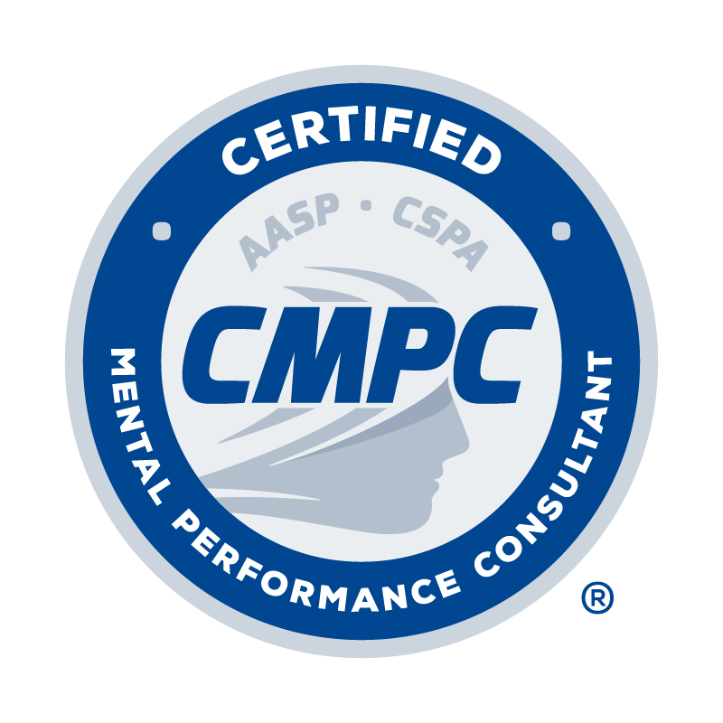

EXPERIENCED PRACTITIONER
APPLICATION FORM

Certified Mental Performance Consultant®
(CMPC®)

Application Date:

I. PERSONAL INFORMATION

Last Name: First Name: M.I.: Maiden/Other Name:

Current Affiliation and Position:

Home Address: check if preferred mailing address Business Address: check if preferred mailing address
Home Phone: | Business Phone:

Email Address:

II. EDUCATION AND DEGREES

List all universities/colleges attended, beginning with undergraduate college education. A master’s or doctoral degree from a regionally-accredited institution of higher education (or non U.S. equivalent) in an area clearly related to sport science or psychology is required. An official, sealed transcript, or electronic transcript directly from the university’s registrar office, must be provided to verify degree requirements have been met.

Name of Institution | Degree/Specialization | Dates Attended (From/To)

III. PROFESSIONAL EXPERIENCE

List professional experiences completed in which mental performance programs and/or services with participants or coaches in sport, exercise, performing arts, military, or other performance settings were provided. List and describe only eligible experiences providing mental performance programs and/or services, which includes a focus was on helping clients develop and use mental, life, and self-regulatory skills to optimize performance, involvement, enjoyment, and/or personal development in sport or other performance domains. Provide an estimate of the total number of contact hours with sport or other (e.g., exercisers, performing artists, military personnel) performers with whom mental performance programs and/or services were provided. Ten or more years of experiences post-graduation from qualifying master’s or doctoral degree is required. A minimum of 50% of these experiences must have been completed with sport populations.

Evidence of consultations, applied programs and services, or supervised professional experiences (e.g., working as part of a “team” of mental performance consultants/psychologists where regular feedback and consultation was solicited) is required. Evidence of experience includes a curriculum vitae and either an employer verification letter or attestation of experience.

Dates | Sport/Performance Setting | Clientele | Total # of Contact Hours

Brief description of activities and services provided (e.g., individual consultation, group facilitation/consultation, psychoeducational workshops, team-building, assessment, skills/interventions employed, on-site observation, mentorship/supervision received):

Employer verification letter attached I attest that I have completed this experience as described above

Dates | Sport/Performance Setting | Clientele | Total # of Contact Hours

Brief description of activities and services provided (e.g., individual consultation, group facilitation/consultation, psychoeducational workshops, team-building, assessment, skills/interventions employed, on-site observation, mentorship/supervision received):

Employer verification letter attached I attest that I have completed this experience as described above

Dates | Sport/Performance Setting | Clientele | Total # of Contact Hours

Brief description of activities and services provided (e.g., individual consultation, group facilitation/consultation, psychoeducational workshops, team-building, assessment, skills/interventions employed, on-site observation, mentorship/supervision received):

Employer verification letter attached I attest that I have completed this experience as described above

Dates | Sport/Performance Setting | Clientele | Total # of Contact Hours

Brief description of activities and services provided (e.g., individual consultation, group facilitation/consultation, psychoeducational workshops, team-building, assessment, skills/interventions employed, on-site observation, mentorship/supervision received):

Employer verification letter attached I attest that I have completed this experience as described above

Dates | Sport/Performance Setting | Clientele | Total # of Contact Hours

Brief description of activities and services provided (e.g., individual consultation, group facilitation/consultation, psychoeducational workshops, team-building, assessment, skills/interventions employed, on-site observation, mentorship/supervision received):

Employer verification letter attached I attest that I have completed this experience as described above

IV. KNOWLEDGE OF FIELD

List the various ways in which knowledge and contributions to the professional or public knowledge of the field of sport psychology have been accumulated. Knowledge must be evidenced through participation in activities pre- and/or post-graduation of qualifying master’s or doctoral degree in multiple areas outlined below. Acceptable evidence includes a curriculum vitae that lists qualifying activities (e.g., publications, teaching, presentations).

A. Sport Psychology Coursework/Educational Experiences – List coursework/educational experiences you have completed for university credit that provided an understanding of the theory, research, and/or practice of sport psychology.

Institution Course Number Course Title Date Credits

B. Teaching of Sport Psychology Courses – List courses you have taught at a university/college that provided an understanding of the theory, research, and/or practice of sport psychology.

Institution Course Number Course Title Date Credits

C. Attendance at Sport Psychology Professional Conferences – List regional, national, or international conferences you have attended that focused exclusively on sport psychology content.

Name of Conference Location Date

D. Presentations Delivered at Sport Psychology Professional Conference – List presentations you have delivered at regional, national, or international conferences that focused exclusively on sport psychology content.

Title of Presentation Conference Date

E. Participation in Sport Psychology Seminars/Workshops/Clinics – List seminars/workshops/clinics you have participated in that focused exclusively on sport psychology content and were separate from the conferences listed above.

Name of Seminar/Workshop/Clinic Location Date

F. Membership in Sport Psychology Professional Organizations – List sport psychology professional organizations in which you are a member and indicate your involvement with specific committee, positions, etc. within the organization.

Name of Organization Committees, Positions, etc. Dates

G. Sport Psychology Publications – List publications that you have authored that have focused exclusively on sport psychology content.

Title of Publication Name of Journal or Publisher Date

H. Sport Psychology Research/Service Grants and Projects – List grants and projects that you have completed that focused exclusively on sport psychology content.

Title of Project Granting Agency Amount Received Dates

V. Mentorship/Supervision Received

Evidence of having received mentorship, supervision, and/or peer consultation with regard to the provision of services to sport or other performance populations throughout one’s career is required. A minimum of three references from experienced practitioners who functioned as a mentor, supervisor, or peer consultant is required evidence, with at least one of these references being an experienced practitioner who is either certified through AASP or approved to provide mentorship by the Certification Council. An Experienced Practitioner Reference Form must be completed by each reference.

VI. Exam

Applicants are required to obtain a passing score on the certification exam. Applicants are eligible to take the exam following review and approval of the applicant’s degree, coursework/educational experiences, and mentored experience requirements by the Certification Council. Application review follows approximately a 10-12 week timeline. Please note reviews can extend beyond this timeframe pending any questions or concerns that require the Council reviewers to deliberate longer on the submission materials. Applicants are required to schedule and take the exam onsite at a Scantron testing center or via live-online proctoring within 6 months of their application approval. Applicants will receive exam scheduling instructions when they are notified of their application approval.

VII. CONDUCT, ATTESTATION, AND ETHICAL CODE

Answer the following questions and provide an explanation and supporting documentation where appropriate:

1. Have you ever had membership in a professional association denied or revoked? Yes No
If yes, please provide an explanation:

2. Have you ever had an application for a professional license, certification, or registration denied? Yes No
If yes, please provide an explanation:

3. Are you currently the subject of any formal complaint or have you ever had any disciplinary action Yes No
taken against your professional license, certification, or registration?
If yes, please provide an explanation:

4. Are your currently awaiting trial or under indictment for or have you ever been convicted of, pled no Yes No
contest to, or pled guilty to any felony or a misdemeanor other than a minor traffic violation (driving
under the influence is not a minor traffic offense)?
If yes, please provide an explanation:

I have read and understand the Candidate Handbook and agree to abide by the policies of the Certification Council and AASP as described therein, including the confidentiality and disciplinary rules. I understand that the information I provide to the Council may be audited, and I authorize the Council to make any necessary inquiries in this regard.
By applying for certification I agree to adhere to the AASP Ethics Code. I understand that any violation of any portion of the Ethics Code may result in disciplinary action as outlined in the Disciplinary and Complaints Policy.
I certify that the information contained in this application is true, complete, and correct to the best of my knowledge. I understand that submission of false or misleading information at any time may be cause for withdrawal or revocation of this application and/or certification without refund of any fees.

Signature of Applicant Date

Application Checklist

Please review and check the following:

Completed Experienced Practitioner Application Form (typed)

Official transcripts from university/college of qualifying master’s or doctoral degree. List name of institution and check method of submission:

Name of Institution:
Emailed directly from institution Mailed directly from institution Sealed envelope

Curriculum vitae that documents professional experiences listed and qualifying activities listed as evidence of knowledge of the field

Employer verification letters (if indicated)

Signed Experienced Practitioner Reference Form from three mentors/supervisors/peer consultants (at least one who is a Certified Mental Performance Consultant or approved by the Certification Council to provide mentorship)

Signed Attestation/Ethical Code statement, including answers and explanations in response to professional conduct and criminal behavior questions where appropriate

Application Fee ($375). Payment can be made online at https://www.appliedsportpsych.org/payment/.

To submit application:

- Combine and convert the following into a single PDF: (a) completed Experienced Practitioner Application Form, (b) Curriculum vitae, (c) all employer verification letters, (d) three signed Experienced Practitioner Reference Forms, and (e) completed Application Checklist.

- Email PDF to certification@appliedsportpsych.org with the subject line “CMPC Certification Application_First Initial Last Name.”

- Request official transcripts from university/college of qualifying master’s or doctoral degree to be emailed to certification@appliedsportpsych.org or mailed to the address listed below. Alternatively, official transcripts in a sealed envelope can be mailed by the applicant to the address listed below. Only transcripts that are received directly from the university/college registrar or from the applicant in a sealed envelope are considered official:

Certification Council
Association for Applied Sport Psychology
8365 Keystone Crossing, Suite 107
Indianapolis, IN 46240

- Application review follows approximately a 10-12 week timeline. Please note reviews can extend beyond this timeframe pending any questions or concerns that require the Council reviewers to deliberate longer on the submission materials. Incomplete application materials will not be reviewed.

