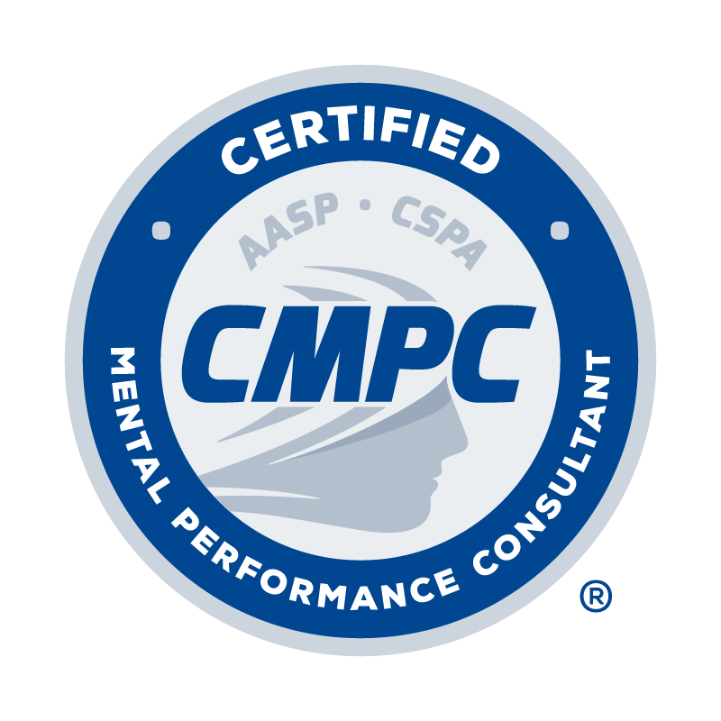

RECERTIFICATION
APPLICATION FORM

Certified Mental Performance Consultant®
(CMPC®)

Application Date: (Applications will only be accepted after September 1 in the renewal year.)

DATE CMPC® CERTIFICATION EXAM COMPLETED: (The exam must be passed first before you apply.)

I. PERSONAL INFORMATION

Last Name: First Name: M.I.: Maiden/Other Name:

Current Affiliation and Position:

Home Address: check if preferred mailing address Business Address: check if preferred mailing address
Home Phone: | Business Phone:

Email Address:

II. CONTINUING EDUCATION (CE) ACTIVITY LOG

Complete the Continuing Education Activity Log by following the instructions provided below. Refer to the Candidate Handbook for requirements related to continuing education units (CEUs), categories of acceptable CE activities, required CE areas, and the prorated system for CEUs for 2017-2021.
- Type of CE Activity: Select the type of CE activity completed from the drop-down menu. Options include Conference, Webinar, Presentation, Workshop, Academic activity, and Self-directed study. Refer to the Candidate Handbook for descriptions of acceptable CE activities.
- Name of CE Activity: Record the title of session/activity completed.
- Hosting Organization: Record the organization that hosted the CE activity.
- Date: Record the date the CE activity occurred.
- # of CEUs: Record the number of CEUs awarded for each activity. Refer to the Candidate Handbook for information regarding the number of CEUs awarded for various activities.
- Required CE Area # of CEUs: If a CE activity fits into one of the required areas, as listed in the Candidate Handbook, record the number of CEUs awarded for the activity in one of the three required areas (PE = Professional Ethics; D = Diversity; M/S = Mentorship/Supervision.
Provide documentation as evidence of completion for each CE activity as outlined in the CE Activity table provided in the Candidate Handbook. Documentation is required for each CE activity as indicated in the CE Activity table.

TYPE OF  CE ACTIVITY | NAME OF CE ACTIVITY | HOSTING ORGANIZATION | DATE | # of CEUs | REQUIRED CE AREA # of CEUs
 |  |  |  |  | PE | D | M/S
Webinar | Best Practices in Supervision for Developing Competent Consultants | AASP | July 2020 | 1.25 |  |  | 1.25
Conference | AASP Conference *note that AASP conferences prior to 2017 are NOT acceptable CE activities | AASP | 10/18/17 – 10/21/17 | 12.00
TOTAL # OF CEUs |  |  |  | 0.00 | 0.00 | 0.00 | 0.00

III. AUDIT AND VERIFICATION PROCESS

The Certification Council reserves the right to verify any information provided on this application. Requests for verification may be made prior to recertification or at a future time.

A portion of recertification applications will be audited to ensure that all renewal requirements are met. Audits may occur up to one year following the renewal deadline; therefore, certificants are required to retain all recertification documentation for at least 1 year after their renewal deadline.

If any areas of non-compliance are identified during the audit (or any review of a recertification application), certificants will have 30 days to submit any required information. If the required information is not provided, the certificant’s certification will expire at the end of the allowed time or on the normal expiration date (whichever comes last). If an application is selected for audit and the certificant does not respond or does not submit the requested documentation, certification will not be renewed.

IV. CONDUCT, ATTESTATION, AND ETHICAL CODE

Answer the following questions and provide an explanation and supporting documentation where appropriate:

1. Have you ever had membership in a professional association denied or revoked? Yes No
If yes, please provide an explanation:

2. Have you ever had an application for a professional license, certification, or registration denied? Yes No
If yes, please provide an explanation:

3. Are you currently the subject of any formal complaint or have you ever had any disciplinary action Yes No
taken against your professional license, certification, or registration?
If yes, please provide an explanation:

4. Are your currently awaiting trial or under indictment for or have you ever been convicted of, pled no Yes No
contest to, or pled guilty to any felony or a misdemeanor other than a minor traffic violation (driving
under the influence is not a minor traffic offense)?
If yes, please provide an explanation:

I have read and understand the Candidate Handbook and agree to abide by the policies of the Certification Council and AASP as described therein, including the confidentiality and disciplinary rules. I understand that the information I provide to the Council may be audited, and I authorize the Council to make any necessary inquiries in this regard.
By applying for certification I agree to adhere to the AASP Ethics Code. I understand that any violation of any portion of the Ethics Code may result in disciplinary action as outlined in the Disciplinary and Complaints Policy.
I certify that the information contained in this application is true, complete, and correct to the best of my knowledge. I understand that submission of false or misleading information at any time may be cause for withdrawal or revocation of this application and/or certification without refund of any fees.

Signature of Applicant Date

Application Checklist

Please review and check the following:

Completed and passed CMPC® Certification Exam (received score report with a “pass” result)

Completed Recertification Application Form (typed)

Completed Continuing Education Activity Log

Supporting documentation for each CE activity listed on Continuing Education Activity Log

Signed Attestation/Ethical Code statement, including answers and explanations in response to professional conduct and criminal behavior questions where appropriate

Application Fee ($275) if not previously paid. Include additional $25 late fee if application is submitted after November 30. Payment can be made online at https://www.appliedsportpsych.org/payment/.

To submit application:

- The recertification period occurs annually from September 1 through November 30. Recertification applications will only be accepted during that time (and during the late period as well). Applications submitted prior to September 1 will be returned.

- Verify that the CMPC® Certification Exam has been completed and passed. Recertification applications will only be accepted if applicants have completed and successfully passed the exam. Applications submitted prior to the completion and passing of the exam will be considered incomplete and returned.

- Combine and convert the following into a single PDF: (a) completed Recertification Application Form, (b) completed Continuing Education Activity Log, (c) supporting documentation for all CE activities, (d) signed Attestation/Ethical Code statement, and (e) completed Application Checklist.

- Email PDF to certification@appliedsportpsych.org with the subject line “CMPC Recertification Application_First Initial Last Name.”

- Only complete application materials will be processed by the Certification Council. Incomplete application materials will be returned, and a corrected and complete application must be submitted by November 30 or by 30 days from the receipt of the returned application (whichever comes last). Complete applications submitted after November 30 or after 30 days from the receipt of the returned application will be considered late and assessed a $25 late fee.

- A portion of the applications will be selected for audit and subsequently reviewed and validated by the Certification Council. Applicants who are not selected for audit will be notified of their renewed certification status within 3 weeks of the renewal deadline. Applicants who are selected for audit will be notified of their certification status within 6-8 weeks following the November 30 renewal deadline (or within 6-8 weeks following the December 31 late deadline if application is submitted late.

