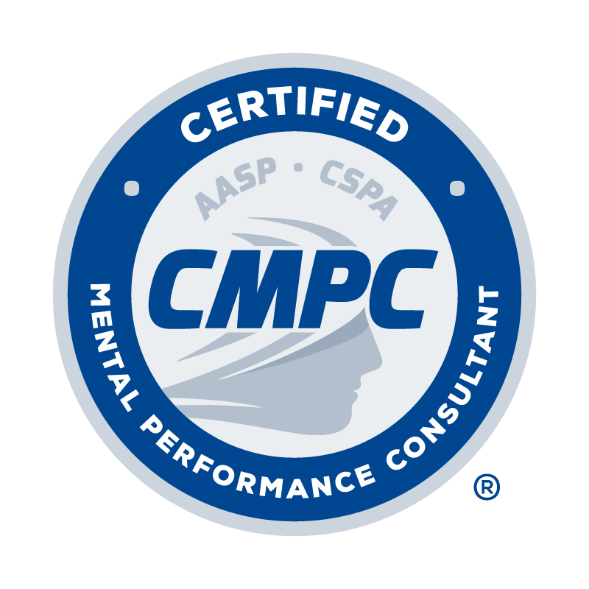

Instructions for Completing the Continuing Education (CE) Activity Log

Complete the Continuing Education Activity Log by following the instructions provided below. Refer to the Candidate Handbook for requirements related to continuing education units (CEUs), categories of acceptable CE activities, required CE areas, and the prorated system for CEUs for 2017-2021.
- Type of CE Activity: Select the type of CE activity completed from the drop-down menu. Options include Conference, Webinar, Presentation, Workshop, Academic activity, and Self-directed study. Refer to the Candidate Handbook for descriptions of acceptable CE activities.
- Name of CE Activity: Record the title of session/activity completed.
- Hosting Organization: Record the organization that hosted the CE activity.
- Date: Record the date the CE activity occurred.
- # of CEUs: Record the number of CEUs awarded for each activity. Refer to the Candidate Handbook for information regarding the number of CEUs awarded for various activities.
- Required CE Area # of CEUs: If a CE activity fits into one of the required areas, as listed in the Candidate Handbook, record the number of CEUs awarded for the activity in one of the three required areas (PE = Professional Ethics; D = Diversity; M/S = Mentorship/Supervision.
Provide documentation as evidence of completion for each CE activity as outlined in the CE Activity table provided in the Candidate Handbook. Documentation is required for each CE activity as indicated in the CE Activity table.

TYPE OF  CE ACTIVITY | NAME OF CE ACTIVITY | HOSTING ORGANIZATION | DATE | # of CEUs | REQUIRED CE AREA # of CEUs
 |  |  |  |  | PE | D | M/S
Webinar | Best Practices in Supervision for Developing Competent Consultants | AASP | July 2020 | 1.25 |  |  | 1.25
Conference | AASP Conference *note that AASP conferences prior to 2017 are NOT acceptable CE activities | AASP | 10/18/17 – 10/21/17 | 12.00
TOTAL # OF CEUs |  |  |  | 0.00 | 0.00 | 0.00 | 0.00

