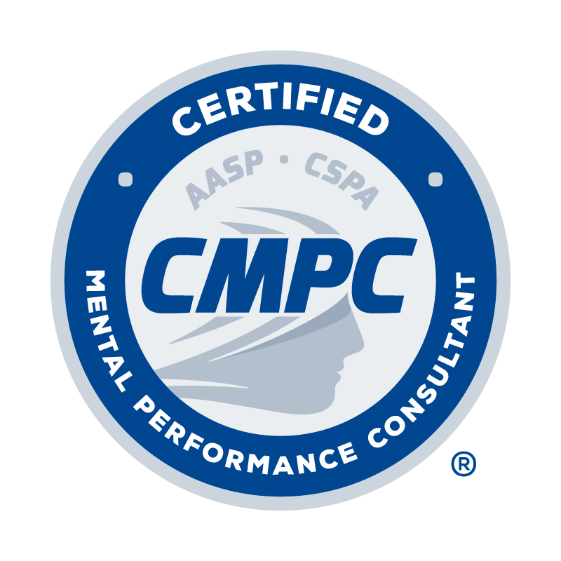

REGISTRY OF APPROVED MENTORS
APPLICATION FORM
(non-CMPC certified mentors)

Application Date:

The Registry of Approved Mentors lists experienced practitioners who devote a substantial amount of their professional time to the practice of applied sport psychology in sport organizations and related settings. They devote significant professional time to the assessment and teaching of mental skills for performance to athletes, teams, and other high-level performers. Their commitment and their identity with the field of sport psychology is exemplified by their long-standing memberships in major sport psychology organizations, attendance and presentations at sport psychology conferences, and other relevant activities. Additionally, they are experienced in the mentoring process by virtue of their own mentored experiences and/or extensive mentoring of students and early career professionals.

Since the CMPC Program is focused on enhancing performance through mental skills training, teaching, providing athletes with counseling or mental health services are not the primary professional activities of those listed in the Registry.

All applicants listed in the Registry of Approved Mentors must provide verification of six hours of continuing education in mentoring/supervision within the past 5 years. This can include a university course, or programs and webinars provided by AASP, CSPA, APA, or other reputable professional organizations.

I. PERSONAL INFORMATION

Last Name: First Name: Middle Initial:

Current Affiliation and Position:

Home Address: check if preferred mailing address Business Address: check if preferred mailing address
Home Phone: | Business Phone:

Email Address:

II. MENTOR QUALIFICATIONS

To be listed in the Registry of Approved Mentors and approved by the Certification Council to provide mentorship, each non-certified mentor must meet established qualifications. Acceptable evidence of the qualifications listed below includes a curriculum vitae or resume. In the spaces provided below, please indicate how you have met each qualification. This information also should be documented on your curriculum vitae or resume:

- Completion of a master’s or doctoral degree from a regionally-accredited institution of higher education (or non U.S. equivalent) in an area clearly related to sport science or psychology. List degrees, universities, and dates of each degree:

- Five or more years of experience post-graduation from qualifying master’s or doctoral degree in providing programs and/or services with participants in sport and/or other performance settings in which the focus was on helping clients develop and use mental, life, and self-regulatory skills to optimize performance, involvement, enjoyment, and/or personal development. Places where sport psychology services have been provided; target populations served; dates when services were rendered; and approximate hours spent in provision of each service.

Additionally, please note if you are or are not currently certified as a CMPC:
I am NOT an active CMPC.
I am an active CMPC.

If you are a CMPC, please complete the appropriate Registry form for certificants. This form is for non-CMPCs.

Places | Target Population | Dates when services were rendered | Approximate hours providing services
Ex. UNL | College baseball/softball | 6/2010 to 5/2013 | 300

- Accumulation of substantial knowledge of the field of sport/performance psychology and/or significant contributions to the professional or public knowledge of the field as evidenced through participation in multiple activities pre- and/or post-graduation of qualifying master’s or doctoral degree, including:
  - completing coursework/educational experience for university credit that provide an understanding of the theory, research, and/or practice of sport/performance psychology. List courses completed related to sport psychology, university, credit hours, and dates:
  - teaching courses that provide an understanding of the theory, research, and/or practice of sport/performance
psychology. List sport psychology courses taught, universities, and dates within the past ten years:
  - attending or presenting at professional sport psychology conferences. List sport psychology conferences attended during the past ten years, dates, and titles of presentations given.
  - belonging to sport psychology professional organizations. List names of sport psychology organizations and dates of membership:
  - publishing sport psychology content. List primary publications, titles, and dates. If this is a lengthy list, refer to CV and highlight the publications.

- Formal training experiences in mentorship/supervision and/or extensive experience providing mentorship/supervision to mentees/supervisees. List your experiences as a mentor: setting, dates, types of mentees, and approximate hours of mentoring.

III. CONTINUING EDUCATION (CE) ACTIVITY LOG

Complete the Continuing Education Activity Log by following the instructions provided below. Refer to the Candidate Handbook for requirements related to continuing education units (CEUs) for approved mentors.
- Type of CE Activity: Select the type of CE activity completed from the dropdown menu. Options include Conference, Webinar, Presentation, Workshop, and Academic Activity. Refer to the Candidate Handbook for descriptions of acceptable CE activities. (Self-Directed Study activities do not qualify for Mentorship/Supervision CEUs; these only apply to general hours needed for recertification.)
- Name of CE Activity: Record the title of session/activity completed.
- Hosting Organization: Record the organization that hosted the CE activity.
- Date: Record the date the CE activity occurred.
- # of CEUs: Record the number of CEUs awarded for each activity. Refer to the Candidate Handbook for information regarding the number of CEUs awarded for various activities.
Provide documentation as evidence of completion for each CE activity as outlined in the CE Activity table provided in the Candidate Handbook. Documentation is required for each CE activity as indicated in the CE Activity table.

TYPE OF  CE ACTIVITY | NAME OF CE ACTIVITY | HOSTING ORGANIZATION | DATE | # of CEUs
Webinar | Best Practices in Supervision for Developing Competent Consultants | AASP | July 2020 | 1.25
TOTAL # OF CEUs |  |  |  | 0.00

IV. ATTESTATION AND ETHICAL CODE

I have read and understand the CMPC Certification Program Candidate Handbook, especially the Mentored Experience Requirements outlined in Section One, and agree to abide by the policies of the Certification Council and AASP as described therein, including the confidentiality and disciplinary rules. I understand that the information I provide to the Certification Council may be audited, and I authorize the Council to make any necessary inquiries in this regard.

By applying for listing in the Registry of Approved Mentors, I agree to adhere to the AASP Ethics Code and to having read the CMPC Mentor Guidelines and Best Practice Recommendations. I understand that any violation of any portion of the AASP Ethics Code may result in disciplinary action as outlined in the Disciplinary and Complaints Policy of the Candidate Handbook.

I certify that the information contained in this application for inclusion in the Registry of Approved Mentors is true, complete, and correct to the best of my knowledge. I understand that the submission of false or misleading information at any time may be the cause for revocation of this application and/or listing in the Registry, without refund of any fees.

Signature of Applicant Date

To submit application:

- Combine and convert the completed application form and curriculum vitae/resume into a single PDF.

Email PDF to Leilani Madrigal, PhD, CMPC, Mentoring Committee Chair, at Leilani.madrigal@csulb.edu with the subject line “Registry Application_First Initial Last Name

