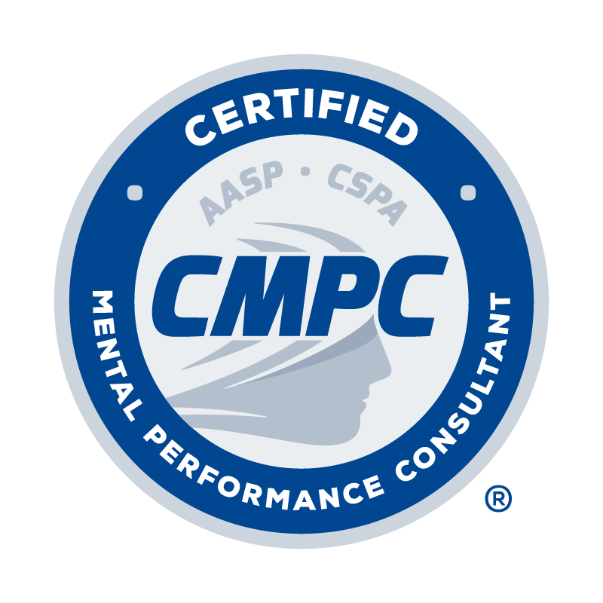

REQUEST TO CHANGE CERTIFICATION STATUS

Certified Mental Performance Consultant®
(CMPC)

Date:

Last Name: First Name: M.I.: Maiden/Other Name:

Home Address: check if preferred mailing address Business Address: check if preferred mailing address
Home Phone: | Business Phone:

Email Address:

Reason for Request:

I hereby request that the Certification Council deactivate my current CMPC certification status and grant me CMPC Emeritus status. My signature below attests to the following:

- I agree to abide by the policies regarding Emeritus status as outlined in the CMPC Certification Program Candidate Handbook.
- I agree to not practice as a CMPC and not use the CMPC credential without adding the Emeritus descriptor (Note: CMPC-Emeritus or Certification Mental Performance Consultant®-Emeritus are acceptable).
- I agree to not provide mentorship as a CMPC for the required mentored experience for applicants pursuing certification unless I have applied for and been accepted for inclusion on the Registry of Approved Mentors.
- I understand that I must pay annual certification maintenance fees of $10 to maintain my Emeritus certification status.
- I understand if I allow my Emeritus certification status to lapse for failure to pay the annual certification maintenance fee that I cannot represent my CMPC credential as being in Emeritus status.
- I understand that I cannot return to CMPC status or use the credential unless I re-apply for certification, meet the eligibility requirements in effect at the time of application, and pass the certification exam.

Signature Date

Please convert the completed form to a PDF and email to certification@appliedsportpsych.org with the subject line “CMPC Certification Change Request_First Initial Last Name.”

